EXPERIMENT – 4

EXP No: 4

Date: ___________

Title
DML Commands – UPDATE and DELETE

AIM
To perform UPDATE and DELETE operations on the Drone Delivery Management System database.

DESCRIPTION
The UPDATE command modifies existing records in a table, while the DELETE command removes records from a table.

PROCEDURE
- Open MySQL Command Line.
- Select the DroneDelivery database.
- Update records using UPDATE.
- Delete records using DELETE.
- Verify the updated tables.

Query 1

USE DroneDelivery;

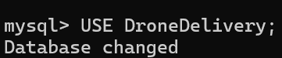

Query 2

UPDATE Customers

SET Address='Chennai'

WHERE CustomerID=101;

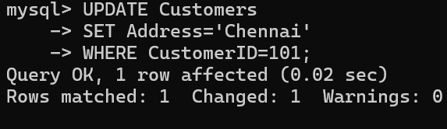

Query 3

UPDATE Drones

SET DroneStatus='Busy'

WHERE DroneID=201;

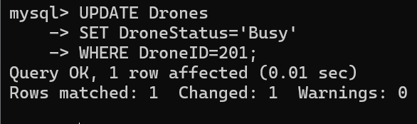

Query 4

UPDATE Deliveries

SET DeliveryStatus='Delivered'

WHERE DeliveryID=302;

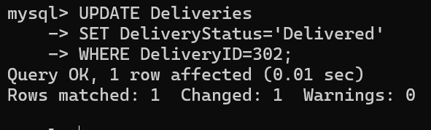

Query 5

SELECT * FROM Customers;

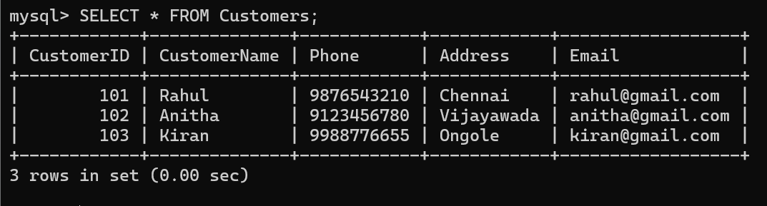

Query 6

SELECT * FROM Drones;

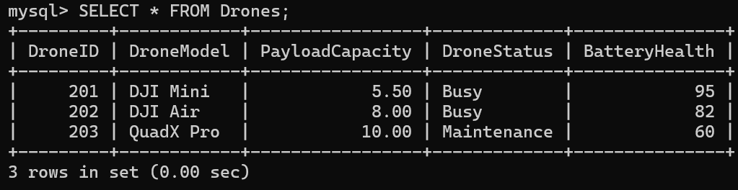

Query 7

SELECT * FROM Deliveries;

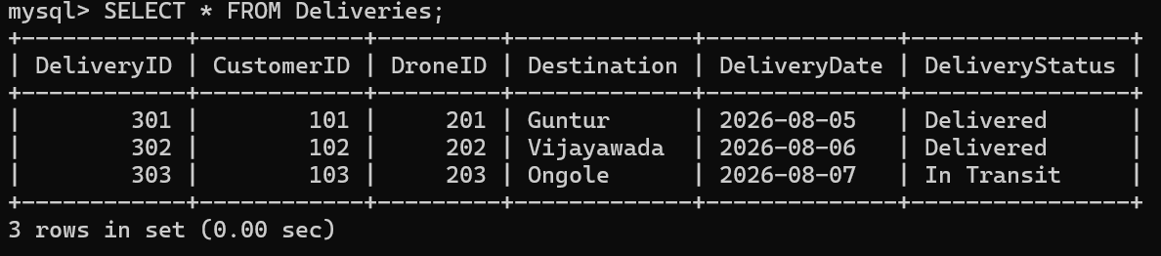

Query 8

SELECT * FROM Deliveries

WHERE CustomerID = 103;

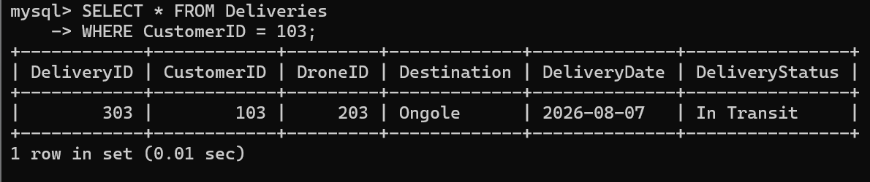

Query 9

DELETE FROM Deliveries

WHERE CustomerID = 103;

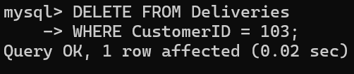

Query 10

DELETE FROM Customers

WHERE CustomerID = 103;

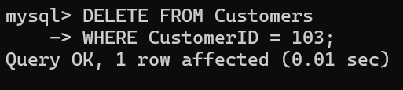

Query 11

SELECT * FROM Customers;

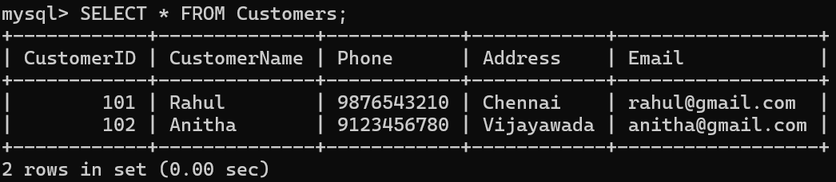

Query 12

SELECT * FROM Deliveries;

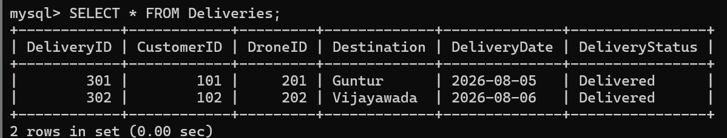

RESULT
Thus, the UPDATE and DELETE operations were successfully performed on the Drone Delivery Management System database.

